Student Paper/Poster Presentation Competition

Association of Pacific Coast Geographers
80th Annual Meeting in Chico, CA
Oct. 25 – Oct. 28, 2017
http://apcgweb.org/

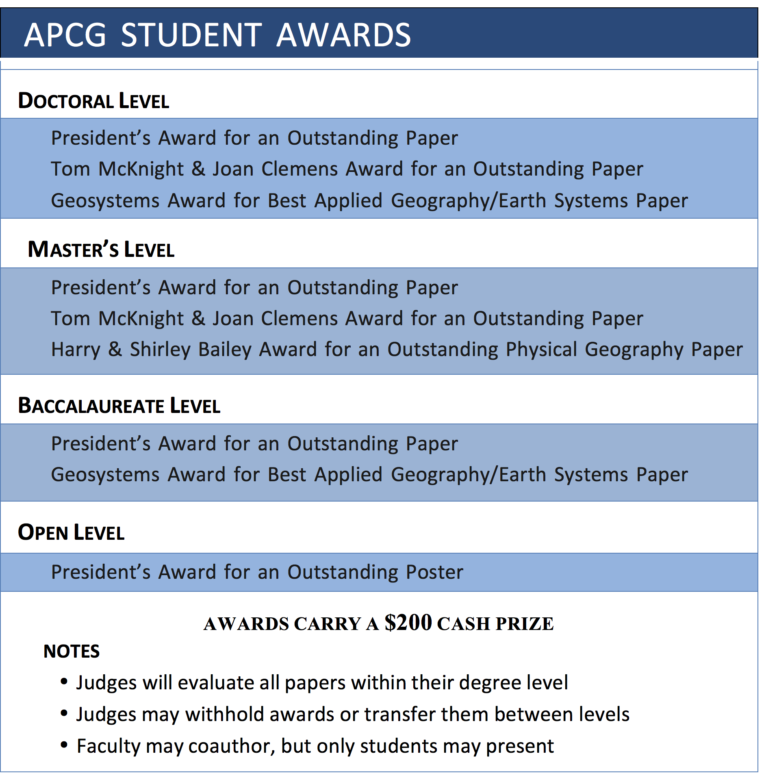

Eligible students must be an APCG member, register for the conference, and submit a short abstract to the conference organizer. Students must also submit a maximum 1,200-word extended abstract and awards application to the Awards Committee Chair, and present at the conference. Judges will evaluate the extended abstract and presentation. For guidelines and application forms, see Grants & Scholarships on the APCG website or contact Awards Chair Stephen Cunha (sc10@humboldt.edu).

For information on the conference, registration, and the call for papers/abstracts visit:
http://apcgweb.org/conferences

The deadline for extended abstract and competition application forms is:
Friday, September 1, 2017

